
#TeamAffordaHouse

Disclaimer: This document is for informational purposes only and should not be construed as financial advice. It is important for you to conduct your own research and exercise due diligence before making any investment decisions. Additionally, if needed, please seek professional financial advice. We do not accept any liability for any financial or personal losses that may occur as a result of your investment actions.

Copyright TeamAffordaHouse 2023—All rights reserved. No part of this publication may be reproduced or transmitted in any form by any means, electronic or mechanical including photocopy, recording or any information storage and retrieval system without permission in writing from the publisher. All materials are proprietary, and discussion should be limited to the stated purposes of this presentation.

Table of contents

1. Project introduction.

2. Current market conditions.

3. Our aims and solution.

4. Business model.

5. Investor opportunities.

6. Business ethics, morals and community.

7. Summary

1 – Project introduction

Welcome investors to TeamAffordaHouse, an exciting opportunity to innovate and make a positive impact on the world. Our project combines the Communities of Cryptocurrency and Housing to address the current housing and economic crisis. In addition to being a lucrative investment opportunity for cryptocurrency enthusiasts, we are dedicated to providing affordable housing in real world communities.

Our unique solution utilizes the power of cryptocurrency to channel much-needed investment into affordable community housing. By reinvesting profits made from trading our token, we will build a portfolio of properties. In turn we will build further sustainable profits through renting out affordable housing, to add value to our currency and solve the housing crisis. Unlike traditional housing projects, we are not driven solely by market valuations and profits. Instead, our focus is on delivering affordable housing while offering a stable investment option to those who support our vision.

At TeamAffordaHouse, we are a small but passionate team based in the UK, determined to create real change. We firmly believe that our model can revolutionize the way housing is provided. In these challenging times, our new currency serves as a stronghold for investors, providing stability amidst market volatility.

In addition to the numerous growth and investment opportunities that await, we pride ourselves on being an ethical and morally upright company, committed to staying true to our principles. We extend a warm invitation to all of you to join this new revolution and help us make a difference.

Don't miss out on this chance to both make money and be a part of something greater. Please continue reading below to learn more.

2. - Current market conditions

In today's challenging economic climate, it has become increasingly difficult for individuals to attain a foothold in the housing market. The rising cost of living and inflation have surpassed the means of many, leading to an unfortunate situation. The constant escalation of inflation and interest rates now poses as the new norm, making it exceedingly challenging to reside in desired communities. As a result, individuals find themselves increasingly dependent on support from their families, facing homelessness, or relying on state assistance.
Regrettably, the current market conditions are not anticipated to improve, and the support from our governing bodies appears lackluster or non-existent. Given the gravity of the situation, it is imperative that we embrace new and innovative approaches to address this crisis. We firmly believe that our organization possesses viable solutions and has the potential to effect positive change.
Similarly, in the realm of cryptocurrency, investments have become highly volatile. Cryptocurrency has become incredibly affected by real market conditions, making it increasingly challenging to find a secure investment option. However, we are confident that our project's unique model will provide a reliable and consistent source of income for our cryptocurrency. Our aim is not to solely rely on user investments, but rather to establish a self-sustaining framework. As a result, our project's value will steadily grow regardless of the fluctuating market conditions.
For those of you who choose to trust and invest in our project, it will undoubtedly prove to be a prudent decision and a remarkable opportunity. Unlike other projects, we possess the capability to calculate gains based on genuine real-world income generated from our properties.

3. - Our aims and solution

Our primary objective for this project is to utilize financial support from our backers and initial investors in order to acquire as many properties as possible under our company name. These properties will be leased at fair, ethical, and affordable rates, making a tangible impact by offering housing options in the market. Additionally, this endeavour will generate a consistent and dependable income for our token. The monthly profits, post expenses, will be reinvested to enhance the value of our token.

This venture presents a unique investment opportunity, offering returns that surpass alternatives. The initial phase of our project focuses on expanding our housing portfolio through strategic marketing, attracting a continuous stream of investors. We aim to provide value to both existing and new investors by rewarding them with additional tokens. We also aim to enhance our online presence and establish a strong foothold in the social media and broader markets.

Once we have established a stable and robust monthly income coupled with a substantial housing portfolio, the potential for growth in our cryptocurrency becomes limitless. This achievement will open doors for us to explore various opportunities as a community. Unlike other projects, our token is not vulnerable to market downturns or declining investor interest. Our consistent monthly income from our property holdings ensures steady growth for our cryptocurrency, independent of investor income.

4. Business model.

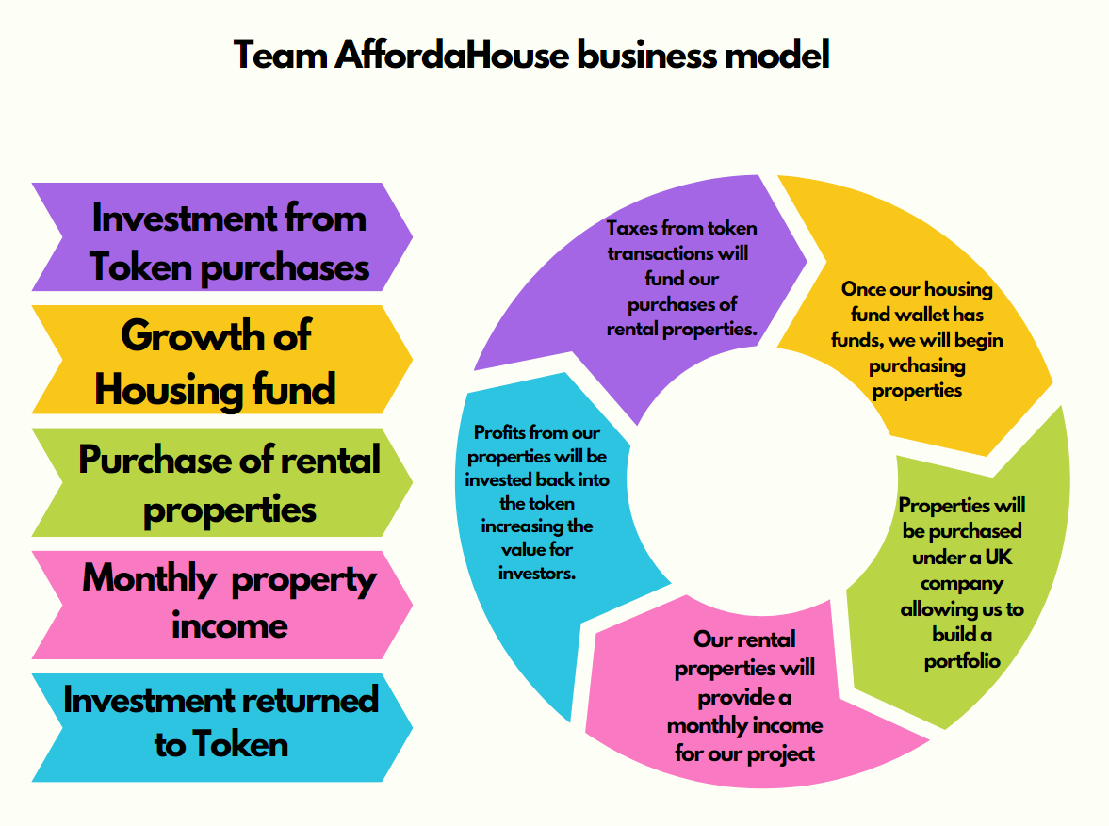

The diagram presented depicts our business model and outlines the process it will follow. At the onset, we will seek an initial investment from our supporters, which will enable us to establish a robust fund for investing in rental properties. The revenue generated by our property portfolio will subsequently yield a stable monthly income, from which a portion of profits will be reinvested into our token. This approach guarantees a return on investment and favourable outcomes for our supporters.

Furthermore, once our property portfolio reaches a sustainable threshold, our business model will no longer depend on additional investments from supporters. The rental income generated by the properties will provide a continual monthly investment in our token, without requiring any further input.

5. Investor opportunities.

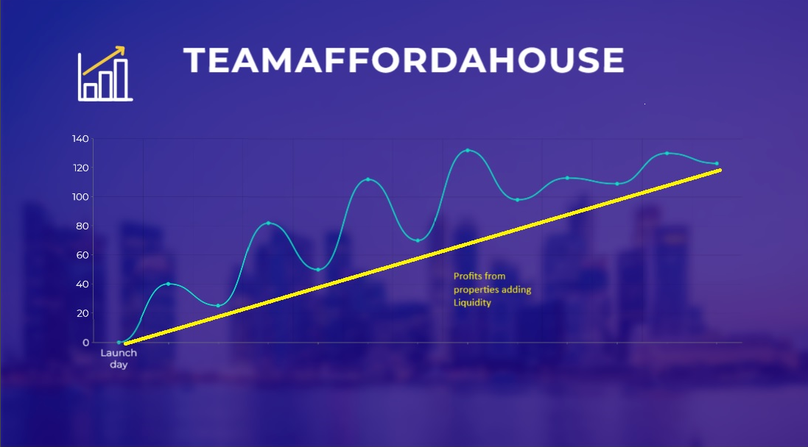

The diagram above illustrates the significant investment potential in our project. Like any typical project, there are market fluctuations resulting in the token value fluctuating. However, what sets us apart from other projects is that our property rentals generate a steady income that continuously adds to the liquidity of our coins on a monthly basis. As a result, the valuation floor of our coins will gradually increase over time. For instance, in other projects, if you purchase a token at an all-time high price, there is a potential for the token's valuation to significantly drop. In our project, even if you purchase our token at an all-time high price, due to the consistent addition of liquidity from our rental properties, the valuation floor of our token will eventually reach the level of your initial investment. This implies that by holding your tokens, you will always experience an increase in the value of your investment. The only way to incur losses when investing with us is to sell your tokens prematurely from an unfavourable position.

6. Business ethics, morals and community.

As an organization, we strive to not only generate profit but also uphold a strong moral and ethical standard. Our aim is to create a supportive network and community. Unlike other property companies, we do not rely solely on income from our properties. This enables us to rent properties in an ethical and affordable manner, truly making a positive impact on the lives of individuals who face regular struggles.
Moving forward, we intend to approach all future opportunities in a similar mindset. We also strongly believe in the involvement of our community and value their input. Unlike other initiatives, we actively listen to our community, respect their feedback, and always act in the best interest of our investors. Our ultimate objective is to make a meaningful difference and be a part of something greater than mere profit-seeking. We aspire to ensure that everyone who interacts with our project has a positive experience and that their needs are fully met. We assume responsibility towards all parties involved, including our investors, renters, and our community.

7. Summary

Our team is fully confident in the potential success of our upcoming projects and the significant impact they will have on society. Additionally, we recognize the remarkable investment opportunity within the cryptocurrency space as a whole. We sincerely appreciate your time spent reading this informational material and sincerely hope to gain your support. Rest assured that we are committed to diligently working towards the triumph of our project and ensuring that we deliver an outstanding investment experience to you.

